RESET ALL LOCKS BEFORE RETURNING!
Reset # Lock to 9310
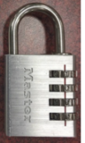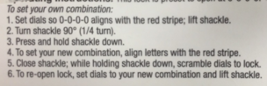
Reset WordLock to SCOTT
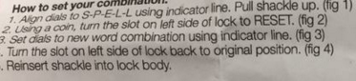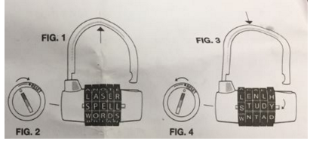
Reset Directional Lock to Up, Down, Left, Right
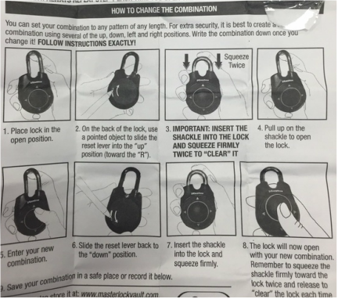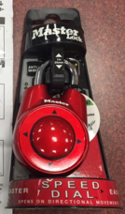
Reset to 189
