How to upload custom backgrounds within Microsoft Teams
Here's how to use your own images for backgrounds within Teams.
- Within a video call, select the More actions button (three dots).
- Select Show background effects.
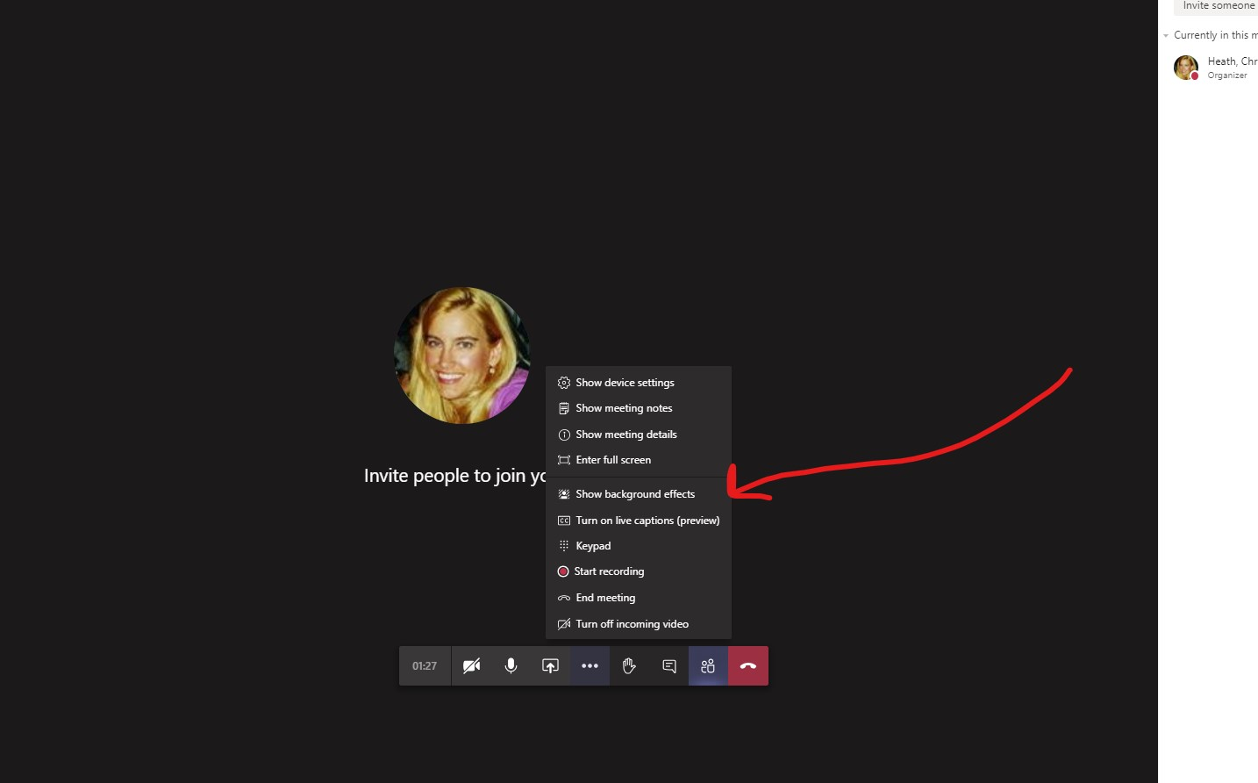

- Select Add new.
- Select the image you'd like to use as a background.
- Select Open.

How to set a custom background in Microsoft Teams
Whether you're setting a background from an image you've uploaded or one of the images that's built into Microsoft Teams, the process is the same.
- Within a video call, select the More actions button (three dots).
- Select Show background effects.
- Scroll down and select the image you've uploaded.
- Select Preview to preview how your background will look (optional).
- Select Apply or Apply and turn on video if your webcam is currently off.

